**DAILY ONLINE ACTIVITIES SUMMARY**

|  |  |  |  |  |  |  |  |  |
| --- | --- | --- | --- | --- | --- | --- | --- | --- |
| **Date:** | **06/06/2020** | | | | | **Name:** | **ASHISH GRACION MENEZES** | |
| **Sem & Sec** | **4&A** | | | | | **USN:** | **4AL18CS012** | |
| **Online Test Summary** | | | | | | | | |
| **Subject** | | **DATA COMMUNICATION** | | | | | | |
| **Max. Marks** | | **30** | | **Score** | | | **26** | |
| **Certification Course Summary** | | | | | | | | |
| **Course** | **ARTIFICIAL INTELLIGENCE IN PYTHOM** | | | | | | | |
| **Certificate Provider** | | | **Great learning** | | **Duration** | | | **7 hours** |
| **Coding Challenges** | | | | | | | | |
| **Problem Statement1:Write a C program to rotate an array by N positions** | | | | | | | | |
| **Status:Executed** | | | | | | | | |
| **Uploaded the report in Github** | | | | | **YES** | | | |
| **If yes Repository name** | | | | | **https://github.com/ash7745/lockdown-coding** | | | |
| **Uploaded the report in slack** | | | | | **YES** | | | |

Online Test Details1:18CS46(D.C.) I.A. 3 was conducted on 06/06/2020.There were 30 questions (MCQ) each question carrying 1 marks. The duration of the test was 45 min . The portion for I.A. 3 was from 5th module

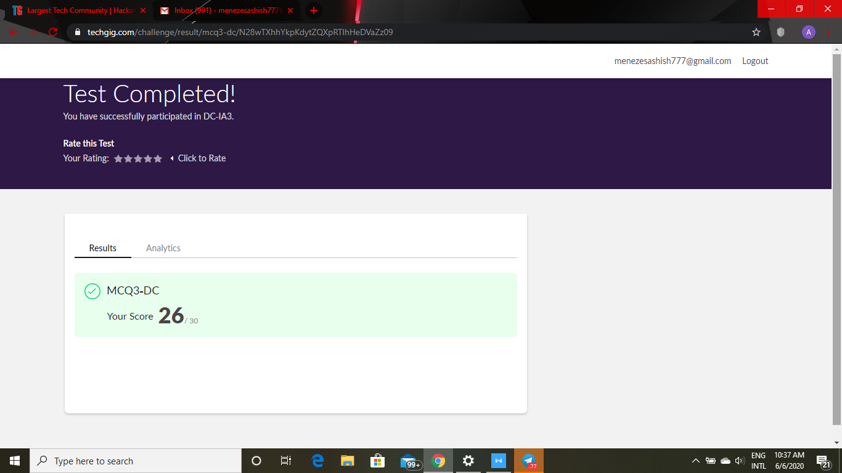

Certification Course Details:”ARTIFICIAL INTELLIGENCE IN PYTHON”

After watching 2 different webinars from past 2 days I have resumed my ongoing certification course and today I have learnt 5 modules each of duration 15,25,55,10,40 mins.

1. Architecture of artificial neureal network
2. Types of activation functions
3. Softmax function
4. Forward propogation
5. Loss function

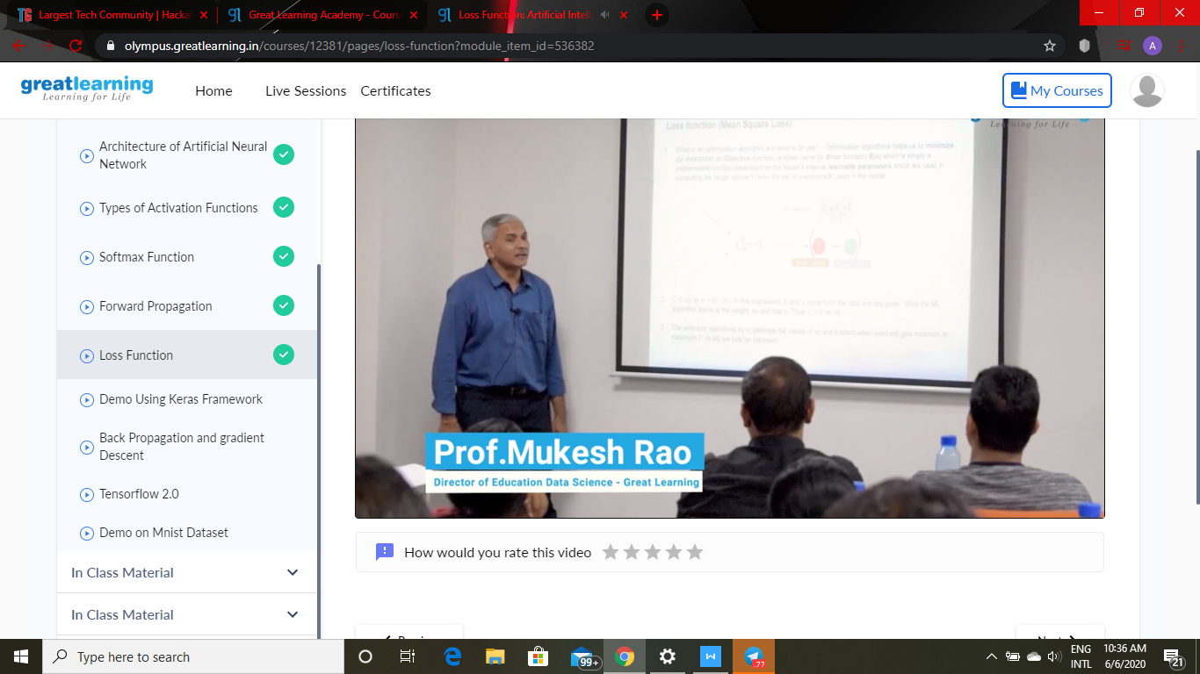

Coding details:Write a C program to rotate an array by N positions

